SELENIUM:

Selenium is a popular software testing tool that is open-source and supports most browsers and operating systems. It’s perhaps most popularly known for allowing testers to automate in any preferred programming language.

How to download selenium:

Go to the official website of selenium(https://www.selenium.dev/)

After getting into website the page will be like in the below:

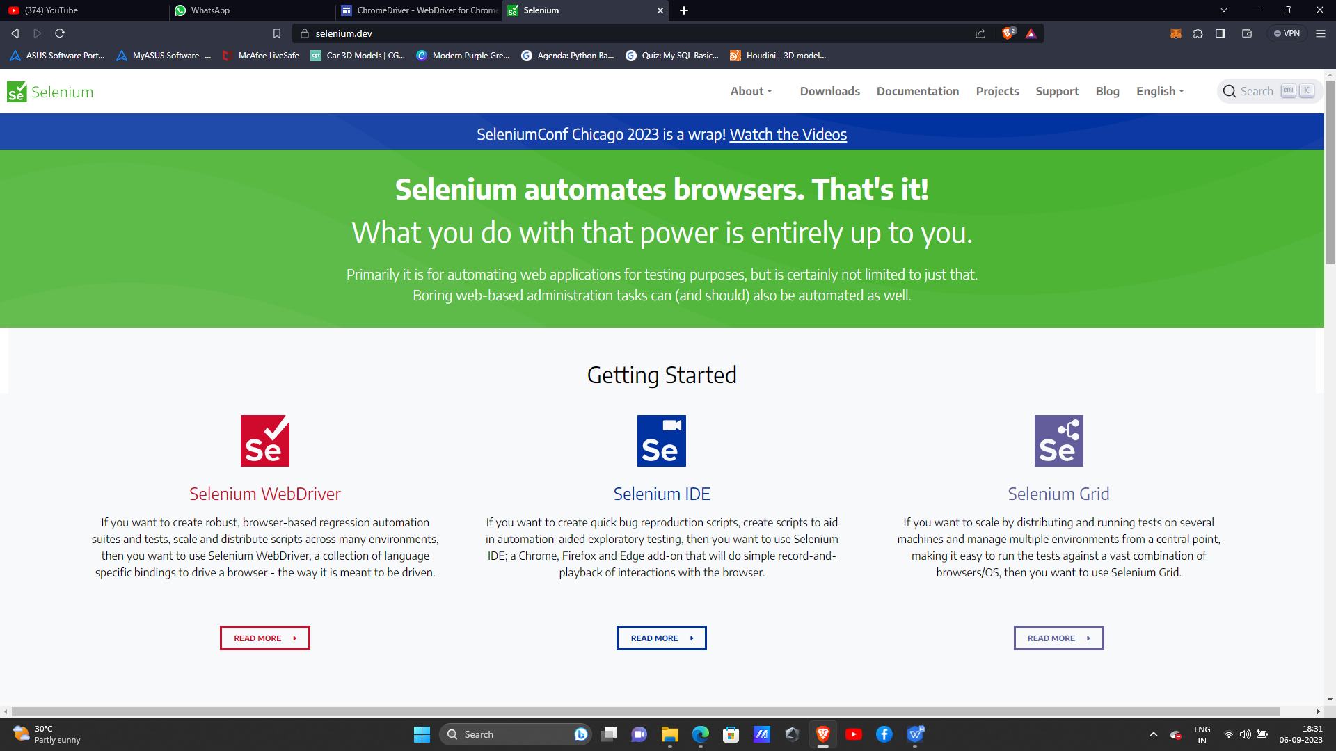

Click on to downloads and the page will like below.And click java and download

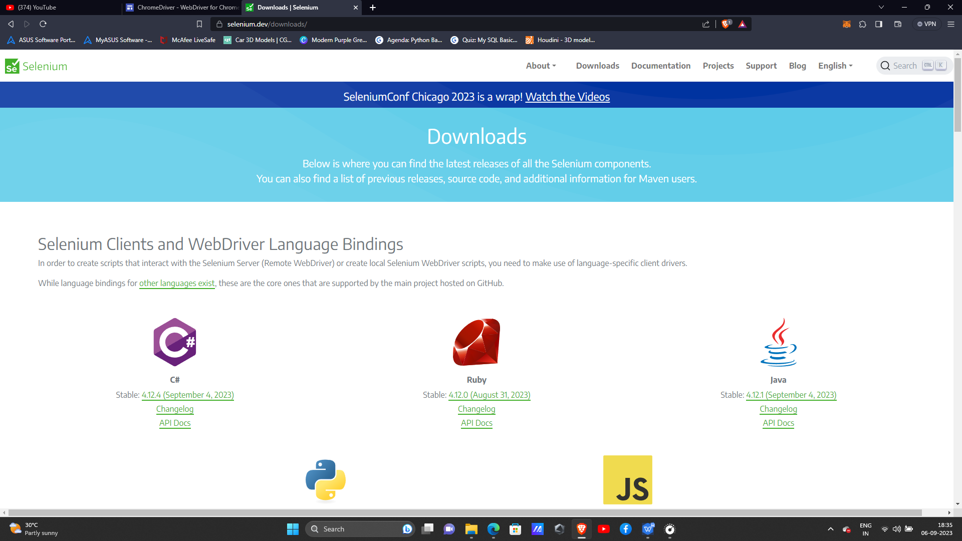

After downloading the selenium the next pae=rt will be downlaoding chromedriver

To downlaod chromedriver(https://chromedriver.chromium.org/downloads)

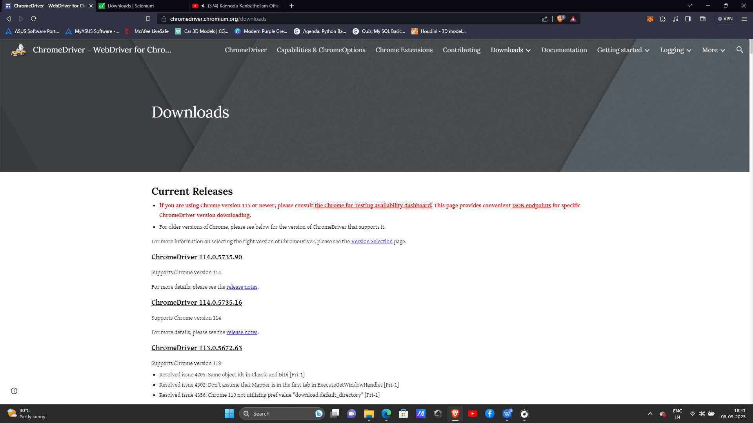

Based on the chrome version your chromedriver wants to be download.

This is for chrome version 1.6

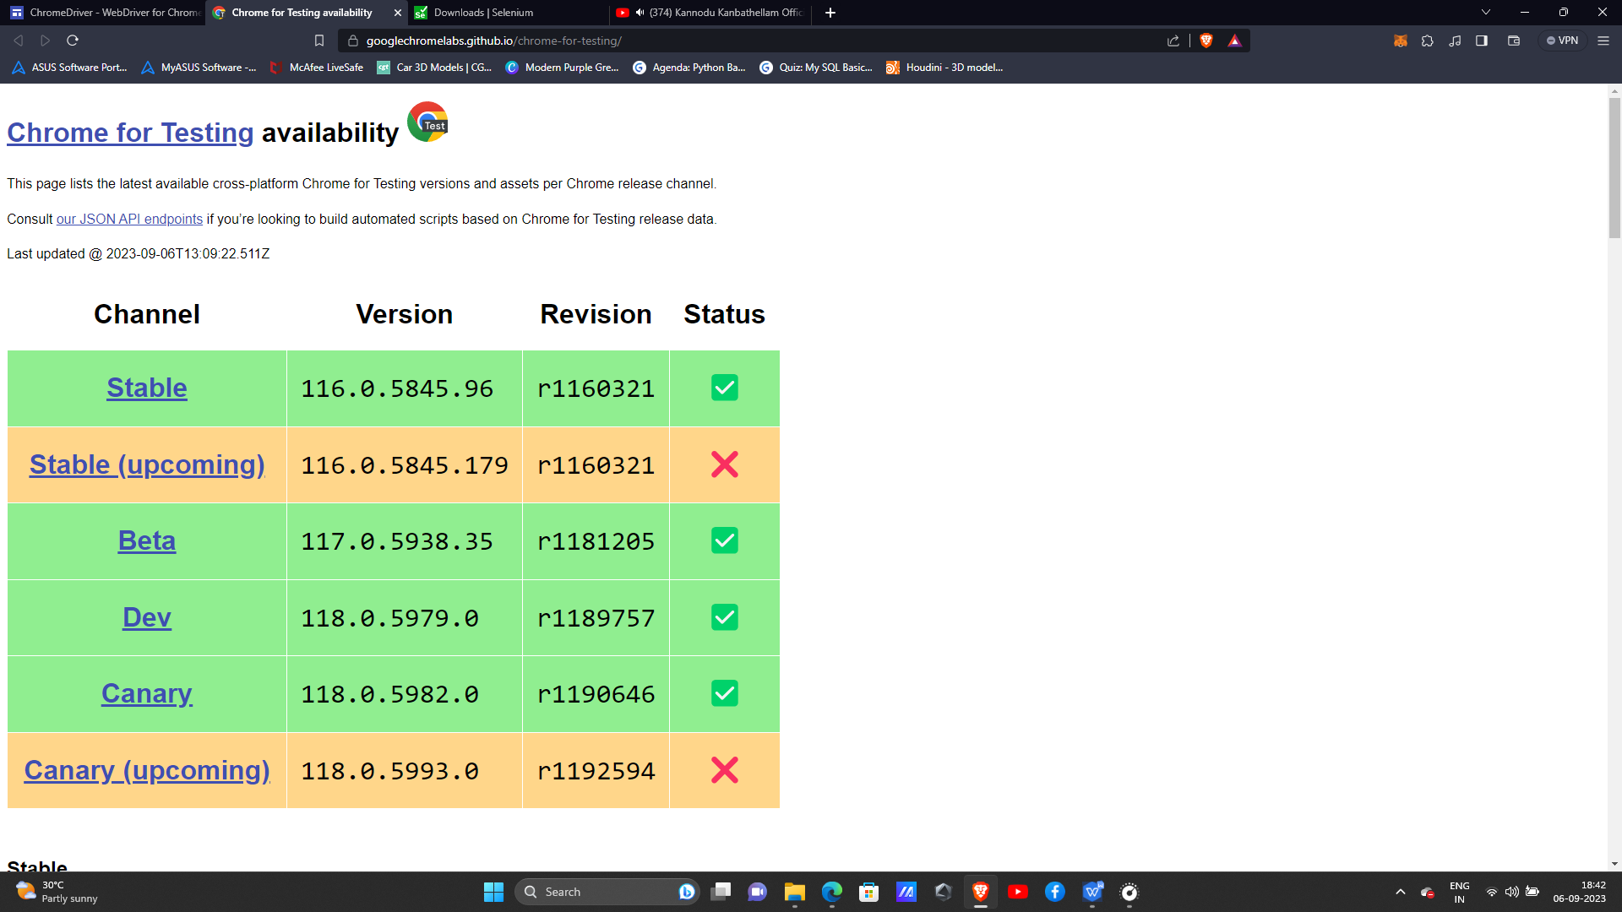

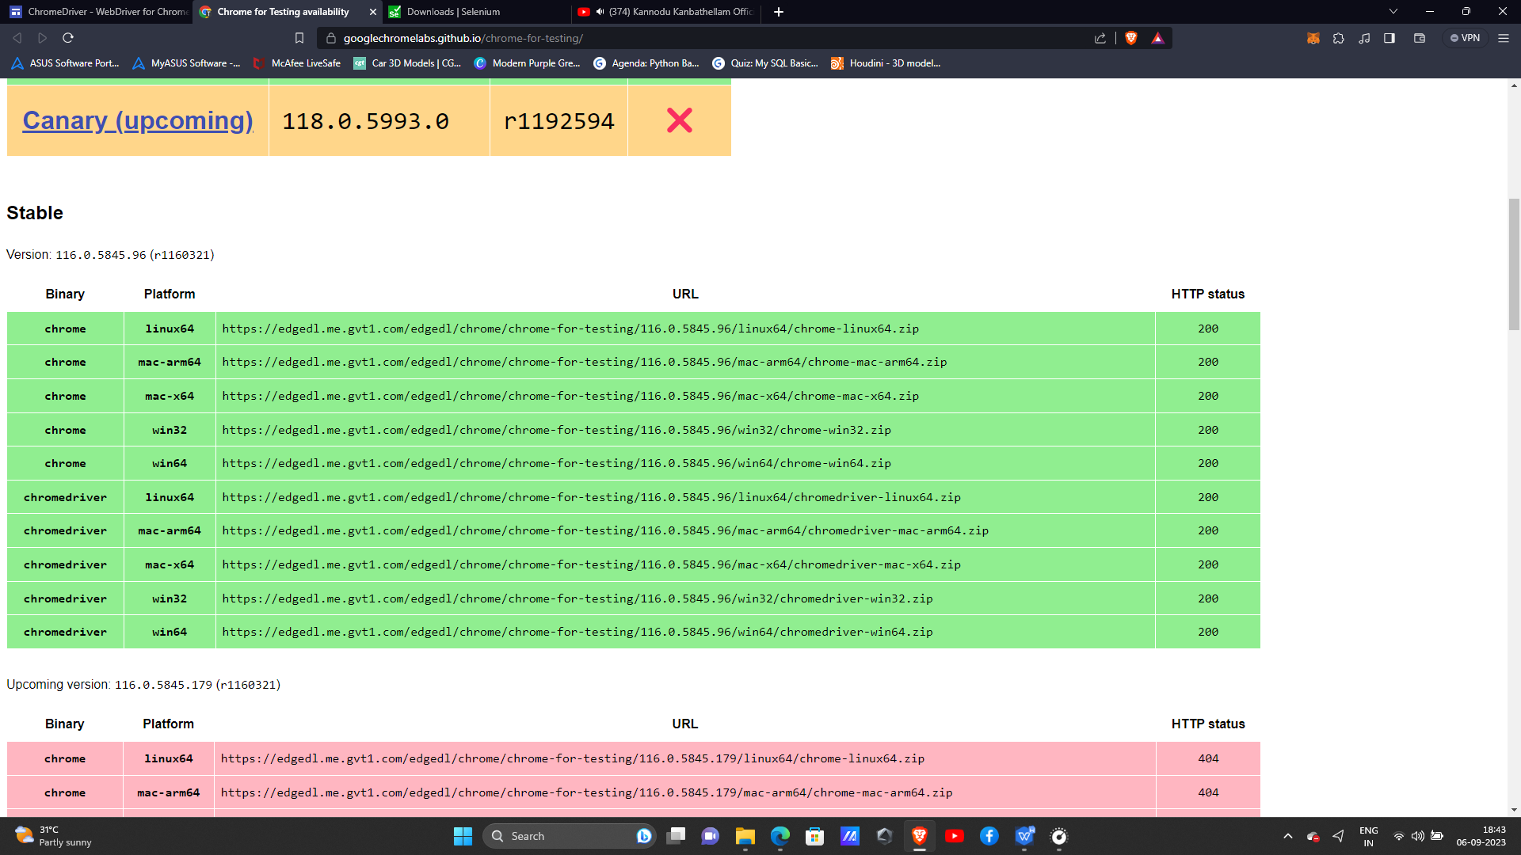

Based on the os and chrome version of the pc the chromedriver wants to be download.

After conforming the version and os copy the particular version link and paste it in google the chromedriver will get downloaded.

The selenium and chromedriver file will be in zip file extract it by right clicking and give extract all.

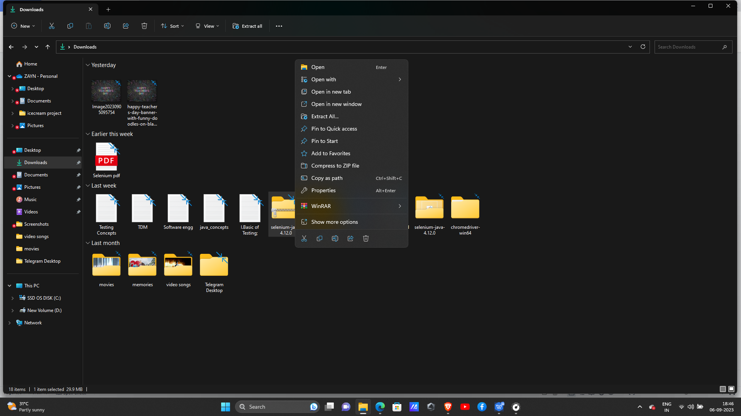

After extraction go to eclipse to configure selenium:

Create a new project using JRE-1.8

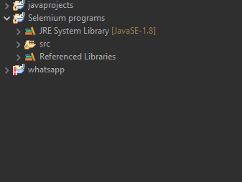

Right click over the project you have created(I.e in this case for me selenium programs is a project name)

Go to buildpath and in that configure build path like the screenshot below

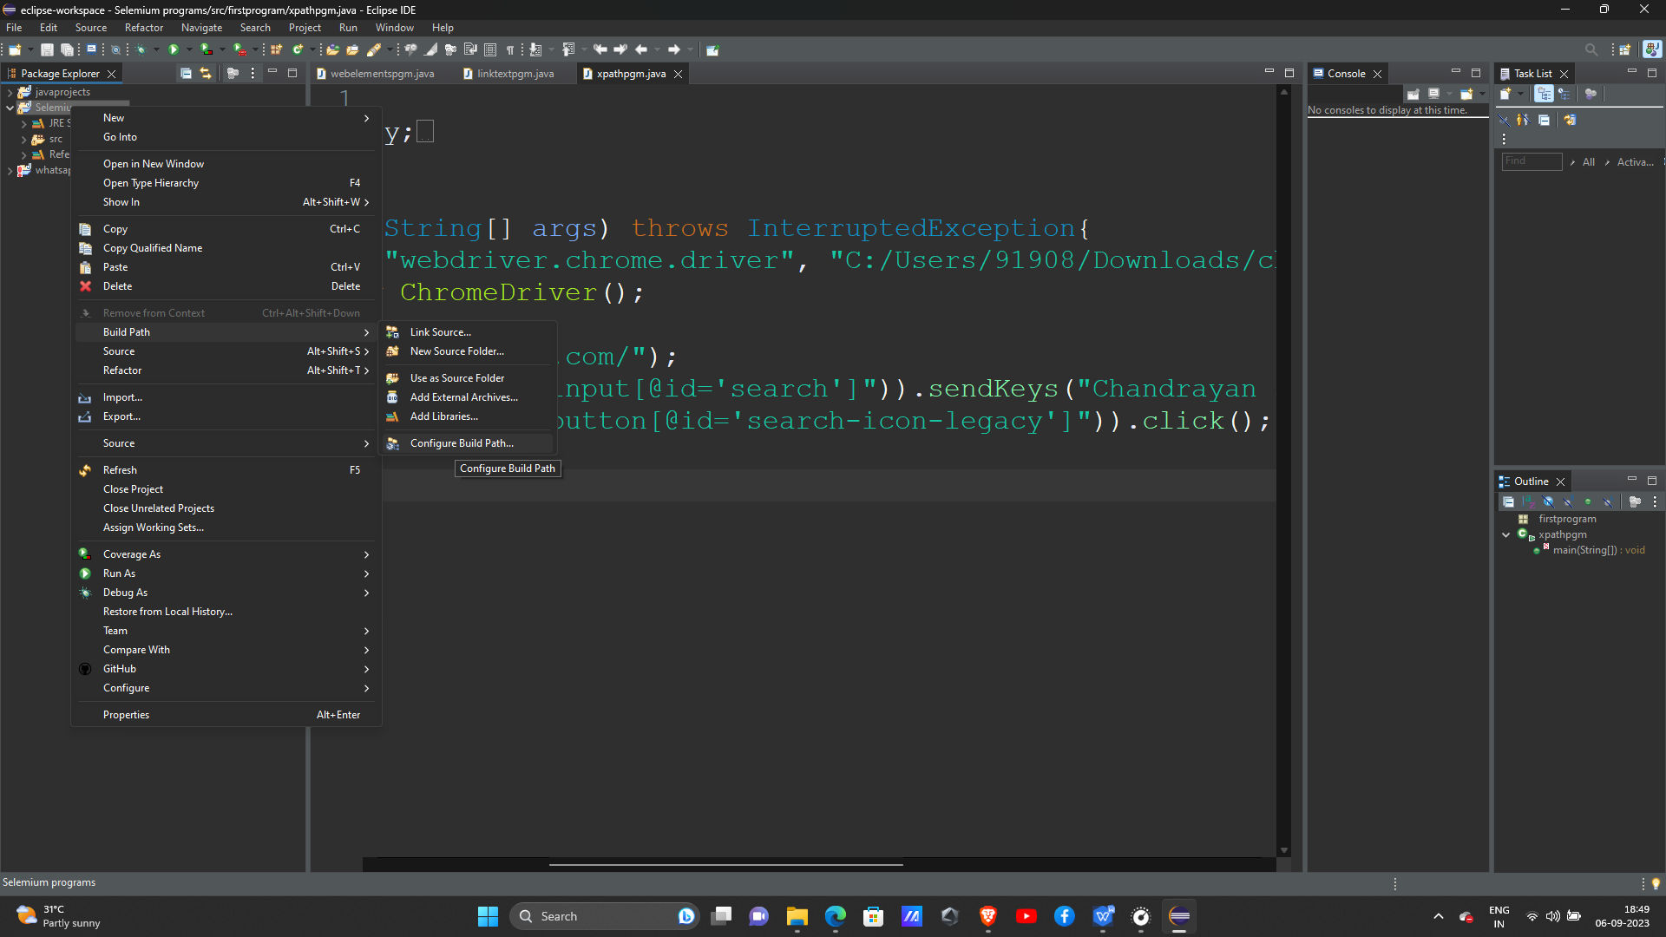

After clicking configure build path you will encounter with a dialog box like this

In that side of box there will be a option called add external jar .

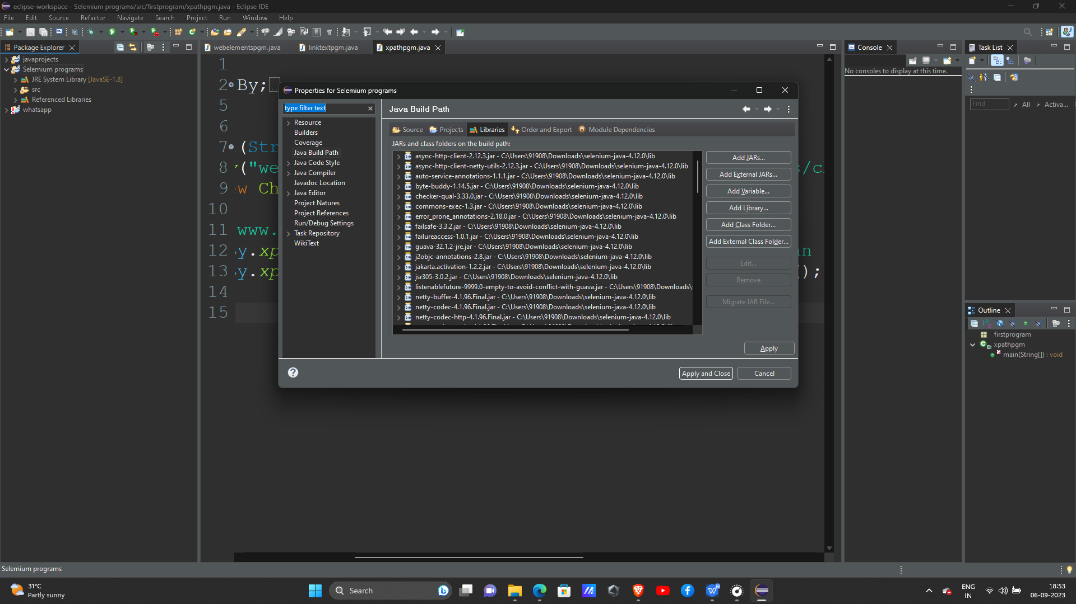

After clicking add external jar the page will be taken to selenium that we extract ang keep

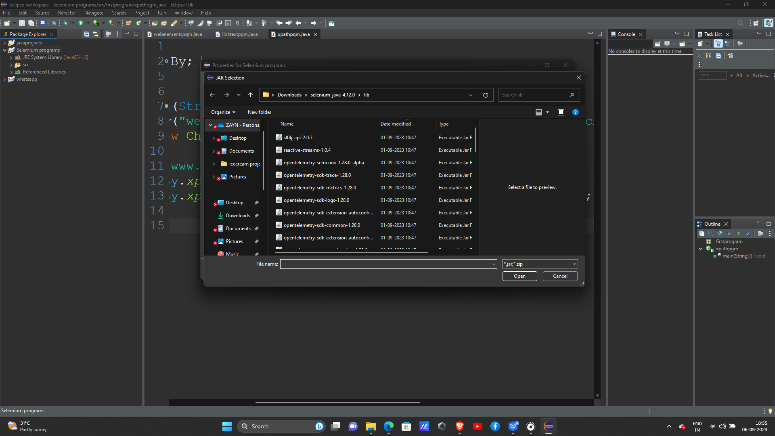

In that copy every file except lib file that will be below and paste in the dialog box

After finshing over this now go to lib files and copy every files and paste it in same dialog box

The box will be like this with full of library files that we copied and paste.

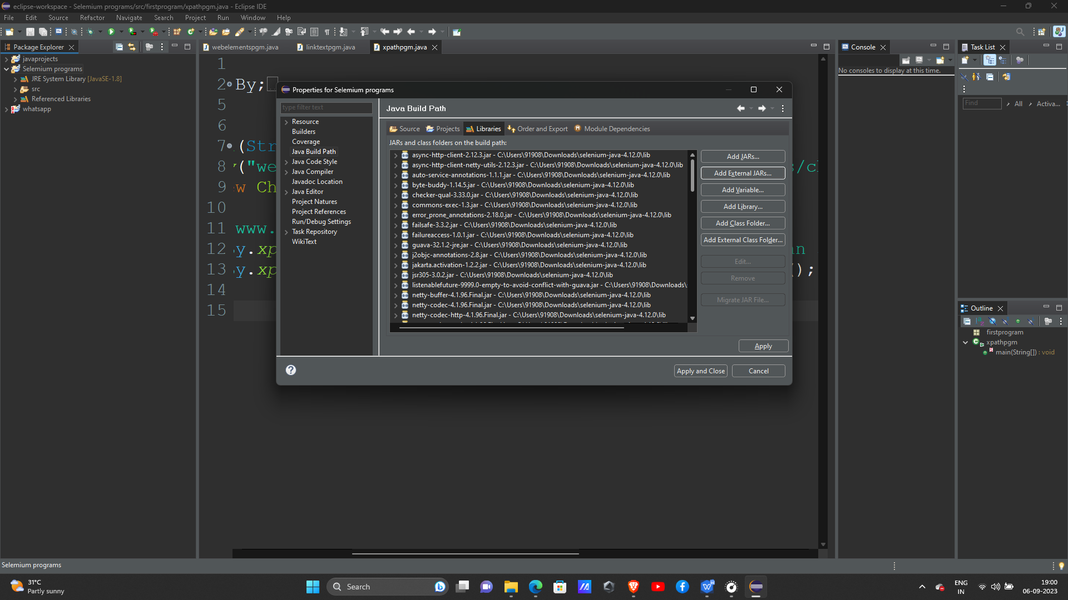

After that as usual create a package and class start the program

IMPORTANT NOTE:

Copy the chrome driver path and paste it in the setproperty with forward slash and chromedriver.exe should be added at last

And the chrome driver should be taken like this in a screenshot below.

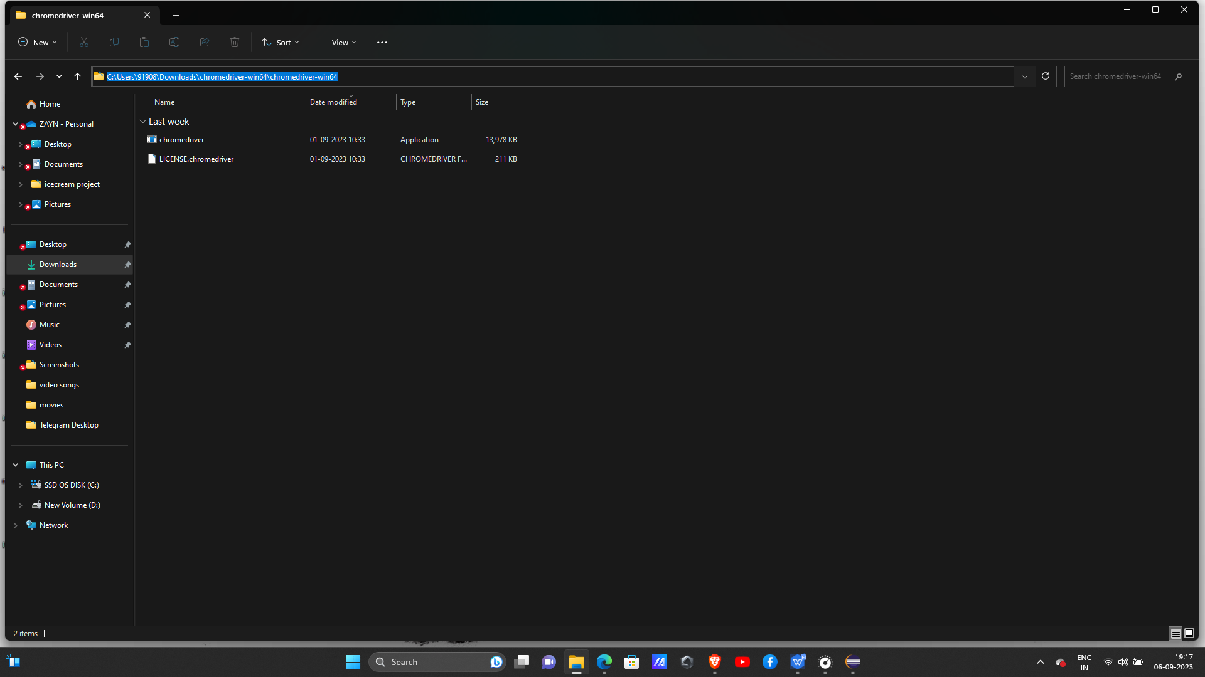

First program :

package firstprogram;

import org.openqa.selenium.By;

import org.openqa.selenium.WebDriver;

import org.openqa.selenium.chrome.ChromeDriver;

public class sampleprogram {

public static void main(String[] args) throws InterruptedException{

System.setProperty("webdriver.chrome.driver", "C:/Users/91908/Downloads/chromedriver-win64/chromedriver-win64/chromedriver.exe");

WebDriver dri=new ChromeDriver();

dri.get("https://www.amazon.in/");

dri.getTitle();

//Thread.sleep(6000);

dri.findElement(By.id("twotabsearchtextbox")).sendKeys("shoes");

dri.findElement(By.id("nav-search-submit-button")).click();

String title = dri.getTitle();//getting title of the page

System.out.println("the title of the page"+" "+title);

dri.navigate().to("https://in.bookmyshow.com/");//navigate to another page

dri.navigate().back();// its navigate amazon back

System.out.println(dri.getTitle());

dri.navigate().forward();//return to book my show

System.out.println(dri.getTitle());

dri.navigate().refresh();

System.out.println(dri.getTitle());

dri.close();

}

}

OUTPUT:

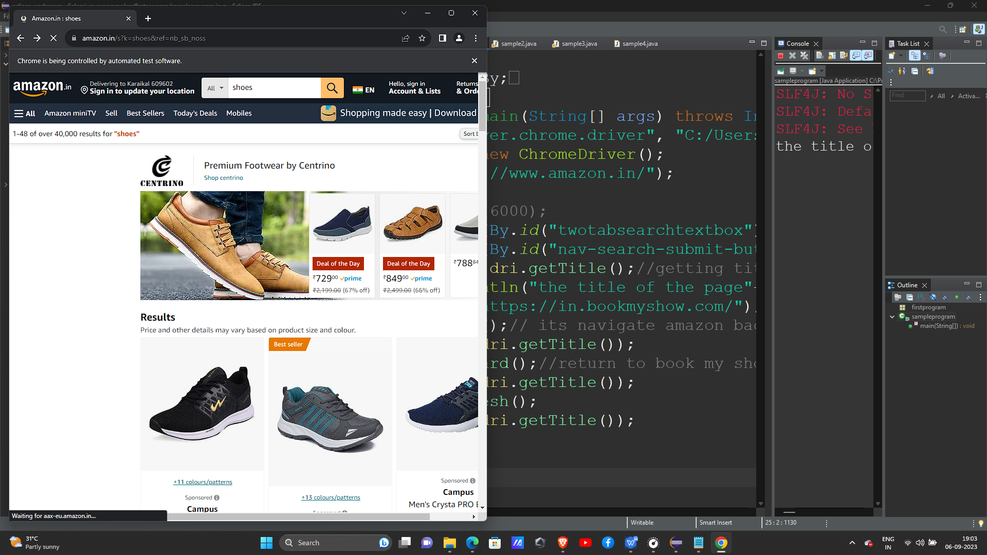

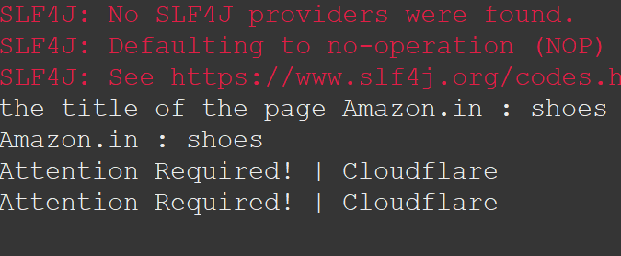

PROGRAM 2:

package firstprogram;

import org.openqa.selenium.By;

import org.openqa.selenium.WebDriver;

import org.openqa.selenium.chrome.ChromeDriver;

public class sample2 {

public static void main(String[] args) throws InterruptedException{

System.setProperty("webdriver.chrome.driver", "C:/Users/91908/Downloads/chromedriver-win64/chromedriver-win64/chromedriver.exe");

WebDriver max =new ChromeDriver();

String url = ("https://www.ajio.com/");//getting url

max.get(url);

String actualUrl =max.getCurrentUrl();

if(actualUrl.equals("https://www.ajio.com/")) {

System.out.println("successful- current url is opened");

}

else {

System.out.println("failed to open");

}

}

}

OUTPUT:

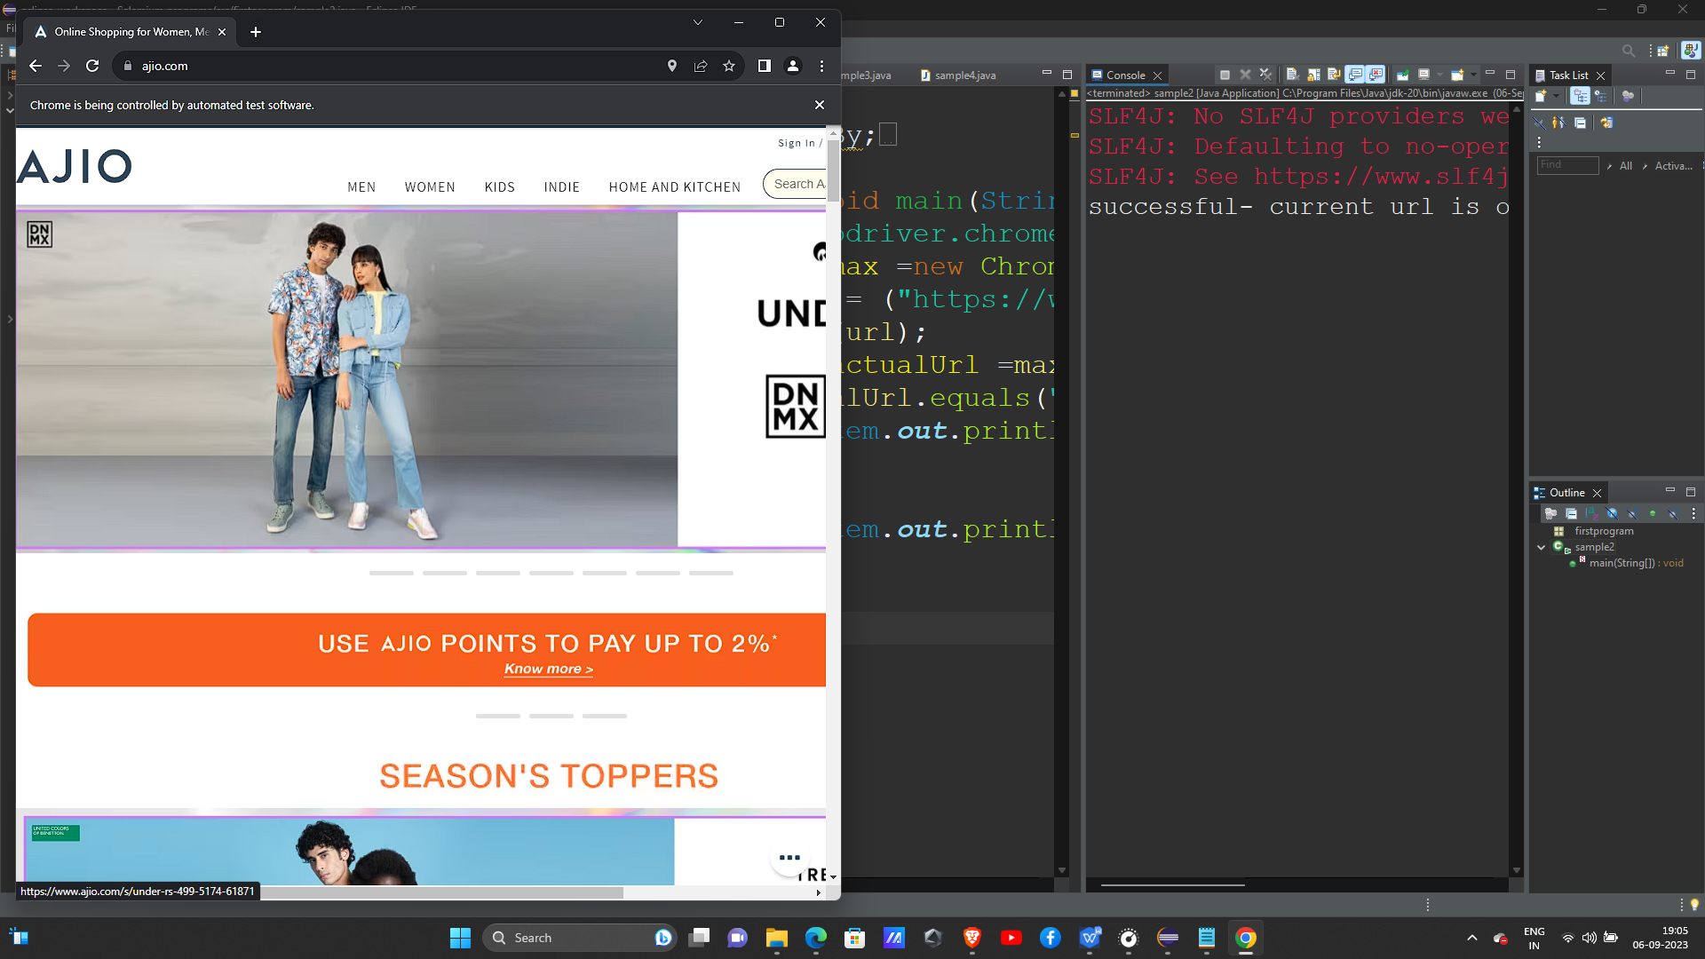

PROGRAM 3:

package firstprogram;

import org.openqa.selenium.By;

import org.openqa.selenium.WebDriver;

import org.openqa.selenium.chrome.ChromeDriver;

public class sample3 {

public static void main(String[] args) throws InterruptedException{

System.setProperty("webdriver.chrome.driver", "C:/Users/91908/Downloads/chromedriver-win64/chromedriver-win64/chromedriver.exe");

WebDriver min =new ChromeDriver();

min.get("https://www.flipkart.com/");

String src = min.getPageSource();//getting page resource

System.out.println("Pagesource is: " + src);

int srcLength = min.getTitle().length();// getting title length.

System.out.println("Length of the title is :" + srcLength);

}}

OUTPUT:

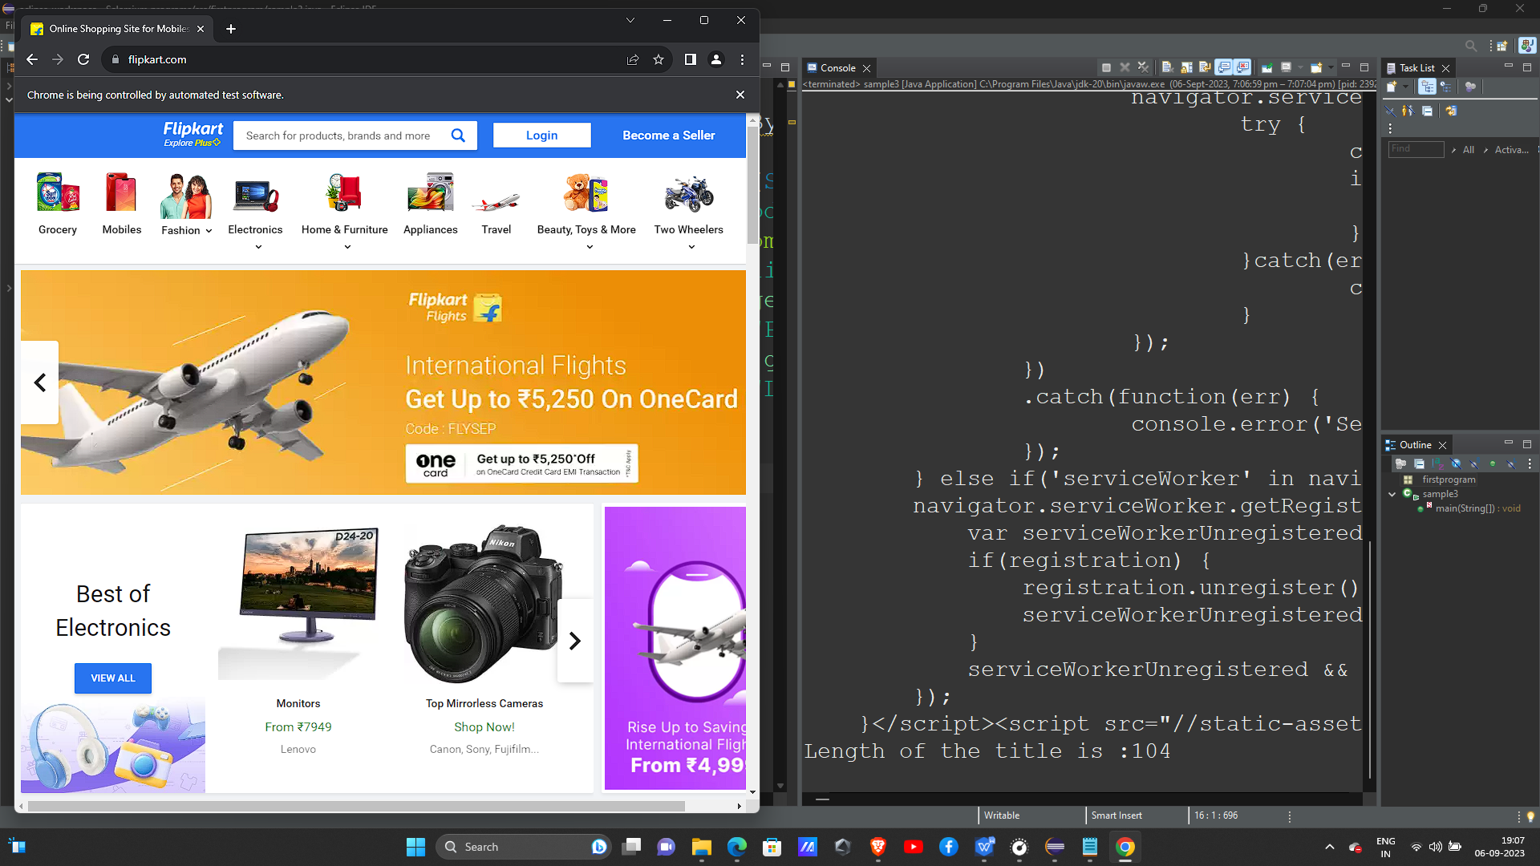

PROGRAM 4:

package firstprogram;

import org.openqa.selenium.By;

import org.openqa.selenium.WebDriver;

import org.openqa.selenium.chrome.ChromeDriver;

public class webelementspgm {

public static void main(String[] args) throws InterruptedException{

System.setProperty("webdriver.chrome.driver", "C:/Users/91908/Downloads/chromedriver-win64/chromedriver-win64/chromedriver.exe");

WebDriver max =new ChromeDriver();

max.get("https://www.google.com/maps/@10.8211663,78.2897649,7z?entry=ttu");

//max.findElement(By.id("searchboxinput")).sendKeys("Chennai");

// max.findElement(By.id("searchbox-searchbutton")).click();//by id

//by name

max.findElement(By.name("q")).sendKeys("Mumbai");

max.findElement(By.id("searchbox-searchbutton")).click();

//by class name

max.navigate().to("https://www.yahoo.com/");

//max.findElement(By.className("_yb_i8yvb")).sendKeys("News");

//max.findElement(By.id("ybar-search")).click();

//tag name

max.findElement(By.tagName("input")).sendKeys("India");

max.findElement(By.id("ybar-search")).click();

}}

OUTPUT:

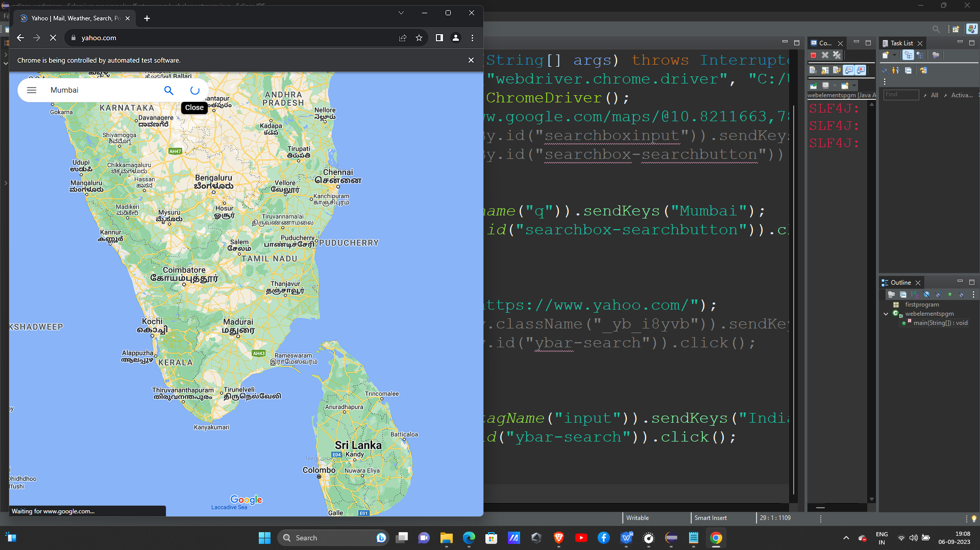

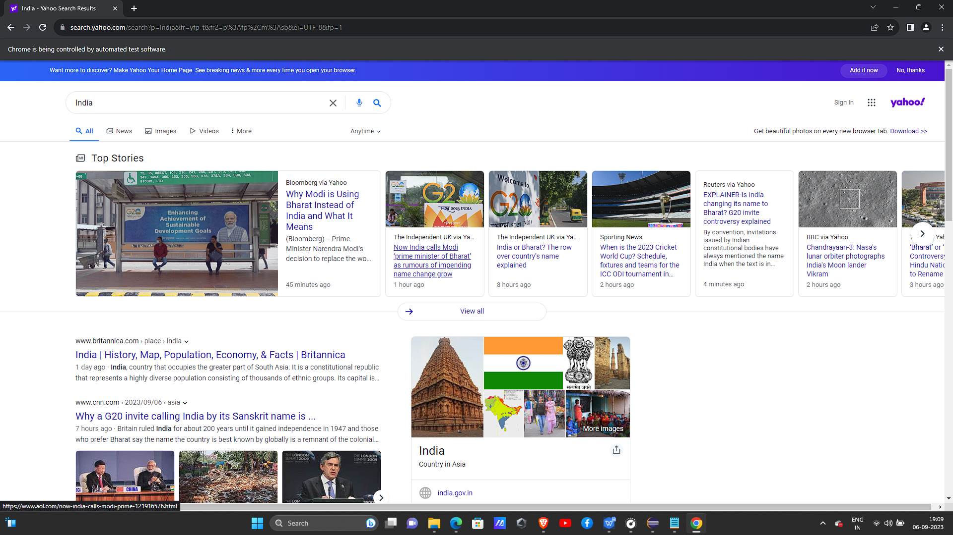

PROGRAM 5:

package firstprogram;

import org.openqa.selenium.By;

import org.openqa.selenium.WebDriver;

import org.openqa.selenium.chrome.ChromeDriver;

public class linktextpgm {

public static void main(String[] args) {

System.setProperty("webdriver.chrome.driver", "C:/Users/91908/Downloads/chromedriver-win64/chromedriver-win64/chromedriver.exe");

WebDriver max1 =new ChromeDriver();

max1.get("https://www.geeksforgeeks.org/");

// max1.findElement(By.linkText("Algorithms")).click();

// max1.findElement(By.partialLinkText("Algori")).click();

//CSS selector

max1.navigate().to("https://www.youtube.com/");

max1.findElement(By.cssSelector("input[id='search']")).sendKeys("india");

max1.findElement(By.id("search-icon-legacy")).click();

}}

OUTPUT:

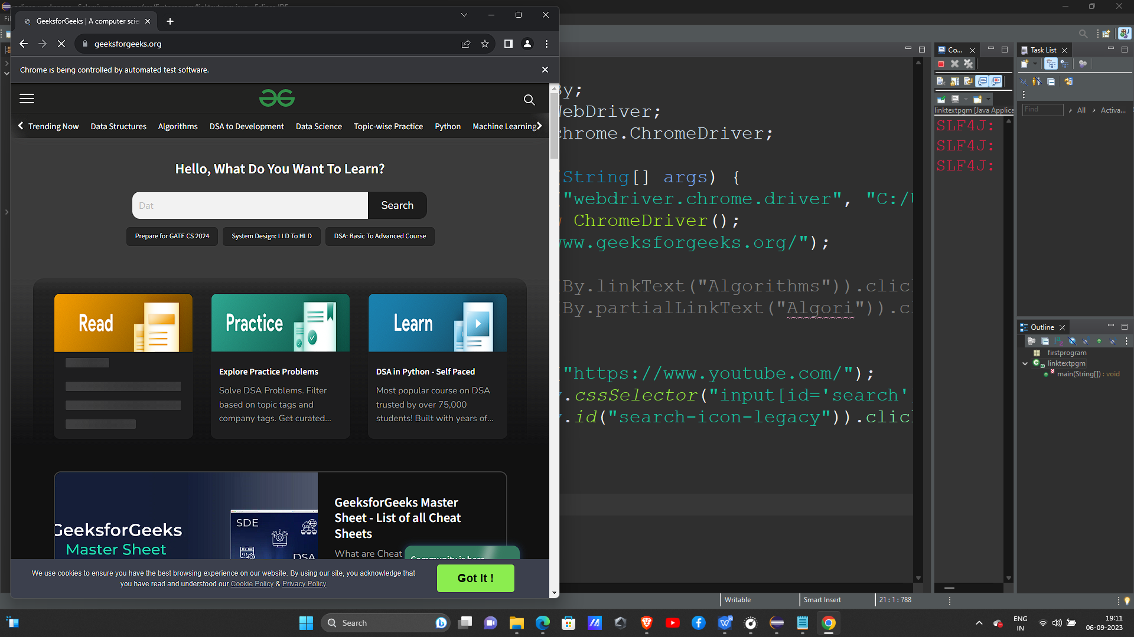

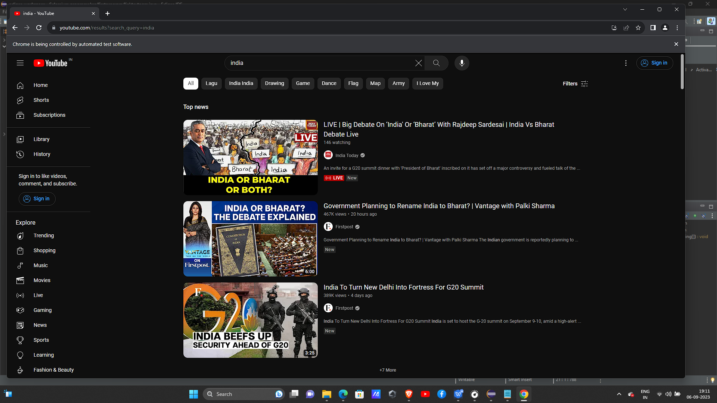

PROGRAM 6:

package firstprogram;

import org.openqa.selenium.By;

import org.openqa.selenium.WebDriver;

import org.openqa.selenium.chrome.ChromeDriver;

public class xpathpgm {

public static void main(String[] args) throws InterruptedException{

System.setProperty("webdriver.chrome.driver", "C:/Users/91908/Downloads/chromedriver-win64/chromedriver-win64/chromedriver.exe");

WebDriver max1 =new ChromeDriver();

//xpath

max1.get("https://www.youtube.com/");

max1.findElement(By.xpath("//input[@id='search']")).sendKeys("Chandrayan 3");

max1.findElement(By.xpath("//button[@id='search-icon-legacy']")).click();

}}

OUTPUT:

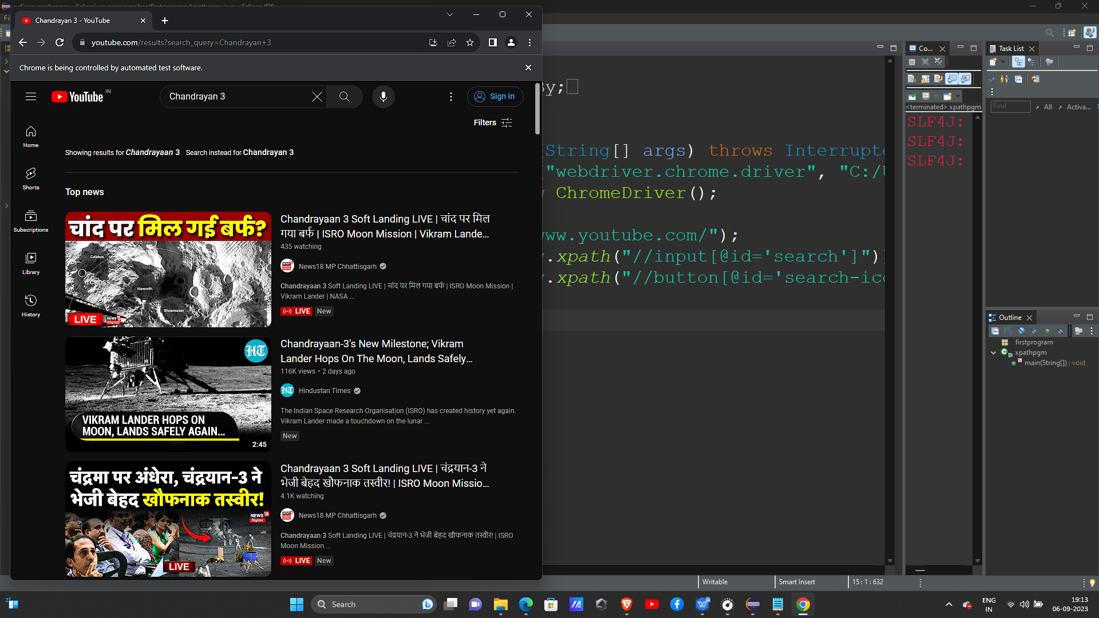

PROGRAM 7:

package firstprogram;

import org.openqa.selenium.By;

import org.openqa.selenium.WebDriver;

import org.openqa.selenium.chrome.ChromeDriver;

public class xpathpgm {

public static void main(String[] args) throws InterruptedException{

System.setProperty("webdriver.chrome.driver", "C:/Users/91908/Downloads/chromedriver-win64/chromedriver-win64/chromedriver.exe");

WebDriver max1 =new ChromeDriver();

//xpath techniques

// max1.get("https://www.youtube.com/");

//single slash

// max1.findElement(By.xpath("/html/body/ytd-app/div[1]/div/ytd-masthead/div[4]/div[2]/ytd-searchbox/form/div[1]/div[1]/input")).sendKeys("News");

//.findElement(By.xpath("/html/body/ytd-app/div[1]/div/ytd-masthead/div[4]/div[2]/ytd-searchbox/button")).click();

//double slash

// max1.findElement(By.xpath("//input")).sendKeys("G20");

// max1.findElement(By.xpath("/html/body/ytd-app/div[1]/div/ytd-masthead/div[4]/div[2]/ytd-searchbox/button")).click();

//@ sign

// max1.findElement(By.xpath("//input[@id='search']")).sendKeys("Chandrayan 3");

// max1.findElement(By.xpath("//button[@id='search-icon-legacy']")).click();

//contains

max1.navigate().to("https://www.google.com/maps/@10.8211663,78.2897649,7z?entry=ttu");

// max1.findElement(By.xpath("//input[contains(@id,'boxinput')]")).sendKeys("Pune"); //id="searchboxinput"

// max1.findElement(By.xpath("//button[contains(@id,'searchbutton')]")).click(); //id="searchbox-searchbutton"

//dot "."

max1.findElement(By.xpath("//input[contains(@id,'searchboxinput')]/.")).sendKeys("Pune");

max1.findElement(By.xpath("//button[contains(@id,'searchbox-searchbutton')]/.")).click();

}}

OUTPUT:

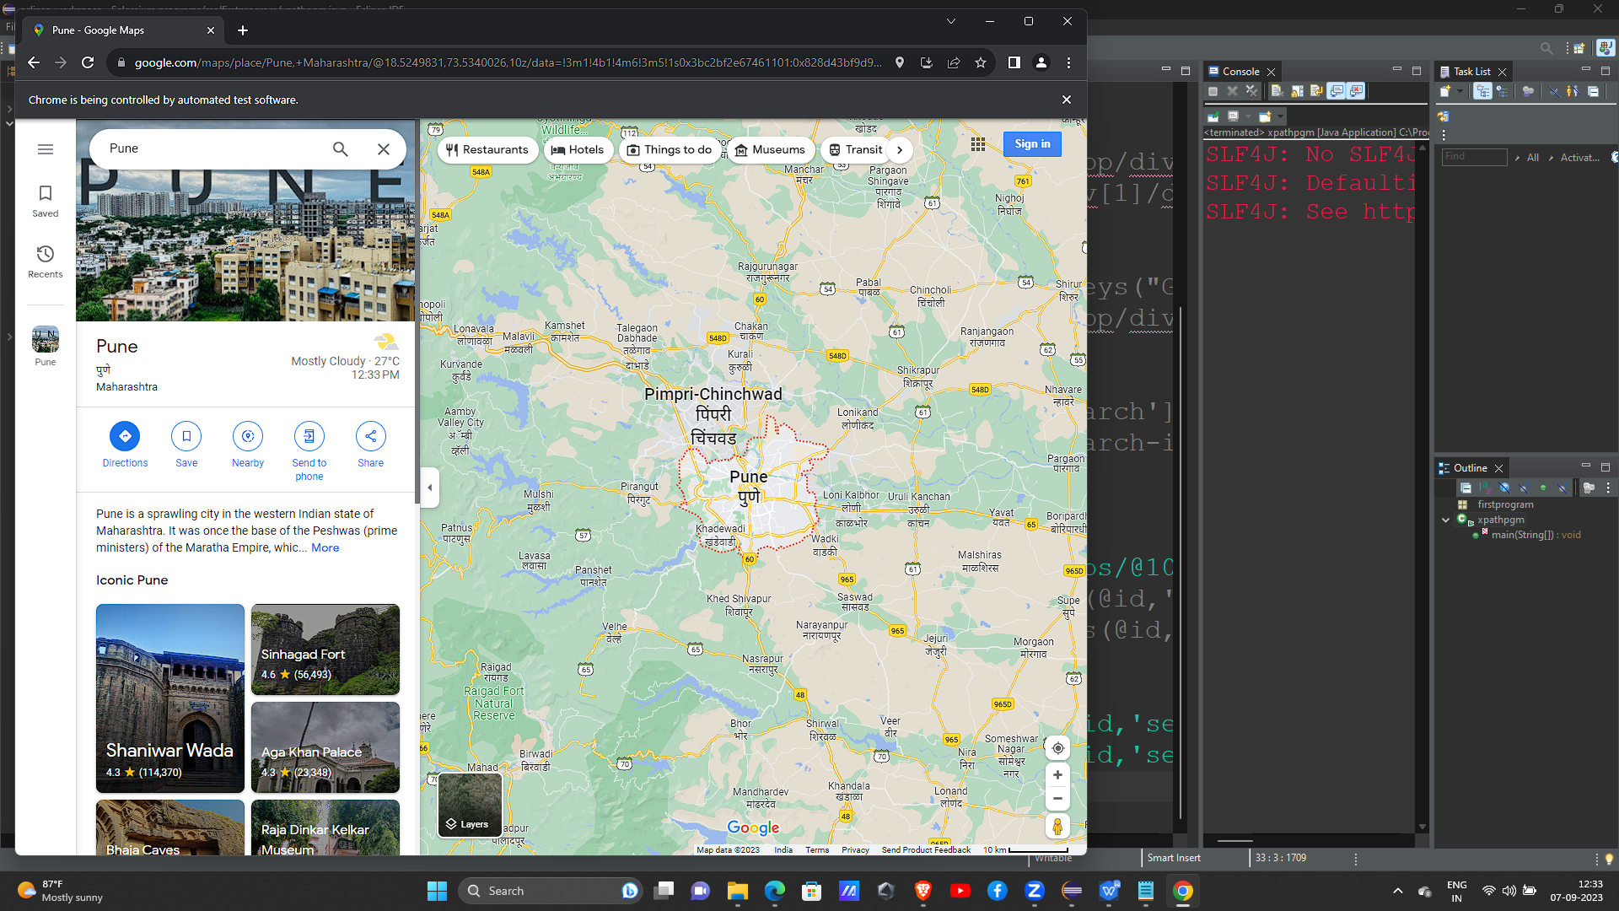

PROGRAM 8:

package firstprogram;

import org.openqa.selenium.By;

import org.openqa.selenium.WebDriver;

import org.openqa.selenium.chrome.ChromeDriver;

public class dotpgm {

public static void main(String[] args) throws InterruptedException{

System.setProperty("webdriver.chrome.driver", "C:/Users/91908/Downloads/chromedriver-win64/chromedriver-win64/chromedriver.exe");

WebDriver max2 =new ChromeDriver();

// max2.get("https://www.youtube.com/");

//piping

//max2.findElement(By.xpath("//input[@* = 'search']|//button[@*='search-icon-legacy']")).sendKeys("Comedy");

//max2.findElement(By.id("search-icon-legacy")).click();

// max2.navigate().to("https://www.geeksforgeeks.org/");

//dot".."

// max2.navigate().to("https://www.google.com/");

//max2.findElement(By.xpath("//textarea[contains(@id,'APjFqb')]/../../div/textarea")).sendKeys("pune");

//max2.findElement(By.xpath("/html/body/div[1]/div[3]/form/div[1]/div[1]/div[1]/div/div[1]/div/span/svg")).click();

// Thread.sleep(1000);

//max2.quit();

//Asterisk "*"

// max2.findElement(By.xpath("//div[contains(@className,'ayzqOc pHiOh')]/div[2]/*")).sendKeys("pune");

//Asterisk @*

// max2.findElement(By.xpath("//div[className@*='ayzqOc pHiOh')]")).click();

}}

OUTPUT:

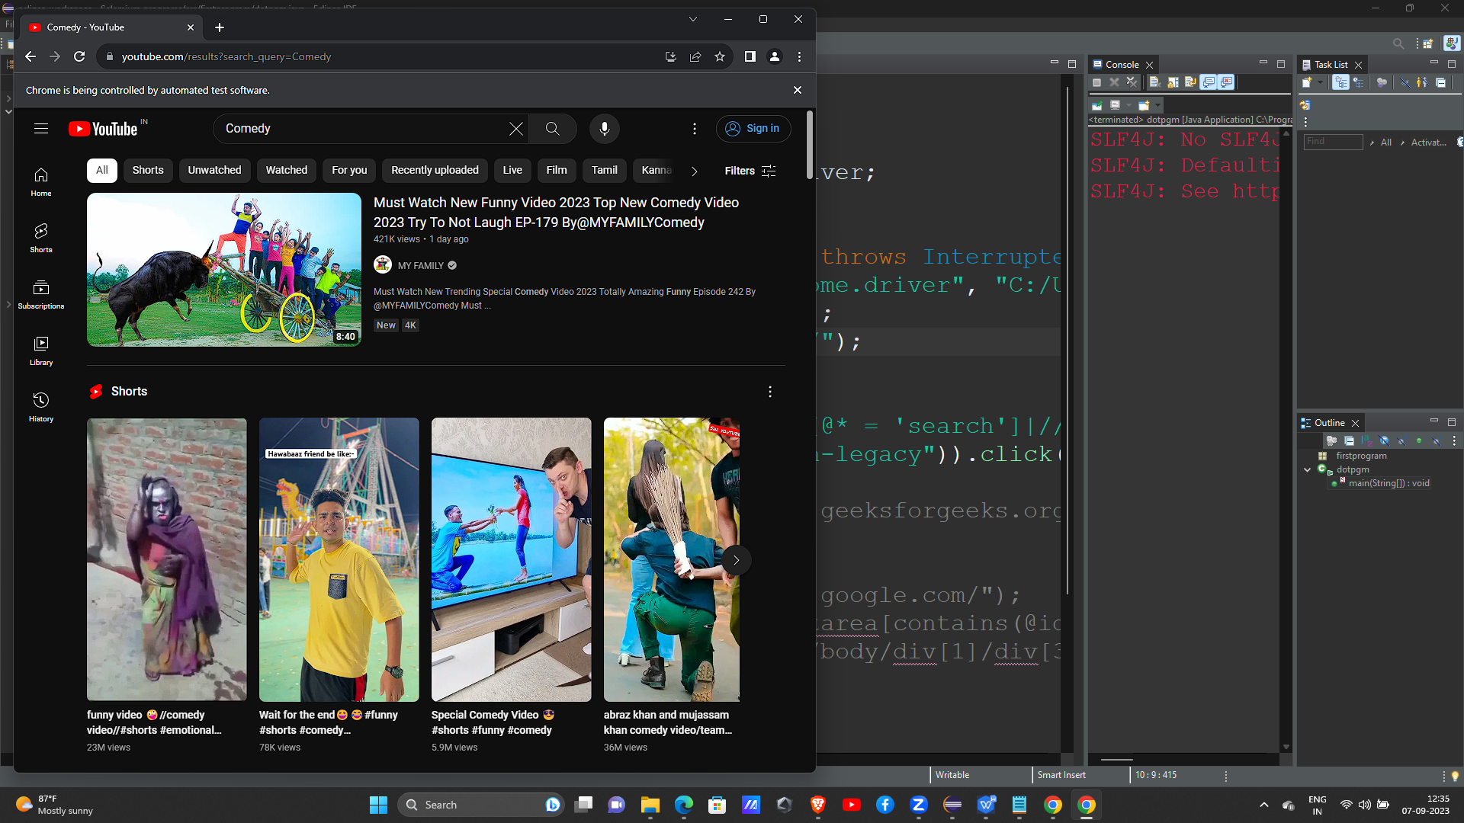

PROGRAM 9:

package firstprogram;

import org.openqa.selenium.By;

import org.openqa.selenium.WebDriver;

import org.openqa.selenium.WebElement;

import org.openqa.selenium.chrome.ChromeDriver;

public class checkbox1 {

public static void main(String[] args) throws InterruptedException{

System.setProperty("webdriver.chrome.driver", "C:/Users/91908/Downloads/chromedriver-win64/chromedriver-win64/chromedriver.exe");

WebDriver abc =new ChromeDriver();

abc.get("https://www.messenger.com/");

//abc.findElement(By.className("_2qcu")).click();

//there are 3 methods to validate checkbox

//***isSelected

//***isDisplayed

//***isEnabled

//is selected

WebElement check= abc.findElement(By.className("_2qcu"));

boolean isSelected = check.isSelected();

System.out.println(isSelected);

if(isSelected == false) {

check.click();

}

// Validate Checkbox using isDisplayed() and click

WebElement check1= abc.findElement(By.className("_2qcu"));

boolean isDisplayed = check1.isDisplayed();

System.out.println(isDisplayed);

// performing click operation if element is displayed

if (isDisplayed == true) {

check1.click();

}

//is enabled

WebElement check2 = abc.findElement(By.className("_2qcu"));

boolean isEnabled = check2.isEnabled();

System.out.println(isEnabled);

// performing click operation if element is enabled

if (isEnabled == true) {

check2.click();

}

/* //checkbox by id locator

abc.findElement(By.id("twotabsearchtextbox")).sendKeys("bags");

//abc.findElement(By.id("nav-search-submit-button")).click();

//by xpath

// abc.findElement(By.xpath("/html/body/div[1]/div[1]/div[1]/div[2]/div/div[3]/span/div[1]/div/div/div[5]/ul/span[2]/li/span/a/div/label/i")).click();

// abc.navigate().to("https://www.irctc.co.in/nget/train-search");

//Validate Checkbox isSelected method and click

WebElement check= abc.findElement(By.id("nav-search-submit-button"));

boolean isSelected = check.isSelected();

System.out.println(isSelected);

//performing click operation if element is not checked

if(isSelected == false) {

check.click();

}

// Validate Checkbox us//ng isDisplayed() and click

/*WebElement check1= abc.findElement(By.xpath("label[for='dateSpecific']"));

boolean isDisplayed = check1.isDisplayed();

// performing click operation if element is displayed

if (isDisplayed == true) {

check1.click();

}*/

}}

OUTPUT:

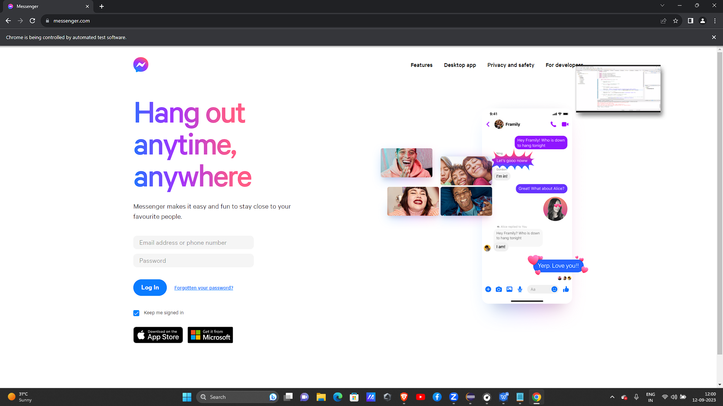

PROGRAM 10:

package firstprogram;

import org.openqa.selenium.By;

import org.openqa.selenium.WebDriver;

import org.openqa.selenium.chrome.ChromeDriver;

import org.openqa.selenium.support.ui.Select;

public class dropdown {

public static void main(String[] args) throws InterruptedException{

System.setProperty("webdriver.chrome.driver", "C:/Users/91908/Downloads/chromedriver-win64/chromedriver-win64/chromedriver.exe");

WebDriver abc1 =new ChromeDriver();

abc1.get("https://www.yahoo.com/");

abc1.manage().window().maximize();

Select se1 = new Select(abc1.findElement(By.name("config.selectedSign")));

se1.selectByIndex(1);

//System.out.println(se1);

//select by value

//Select se2 = new Select(abc1.findElement(By.id("league-select")));

//se2.selectByValue("ncaab");

//System.out.println(se2);

//(driver.findElement(By.xpath("//*[@id='oldSelectMenu']")));

//select by visible text

// Select se3 = new Select(abc1.findElement(By.id("horoscope-select")));

//se3.selectByVisibleText("Libra");

}}

OUTPUT:

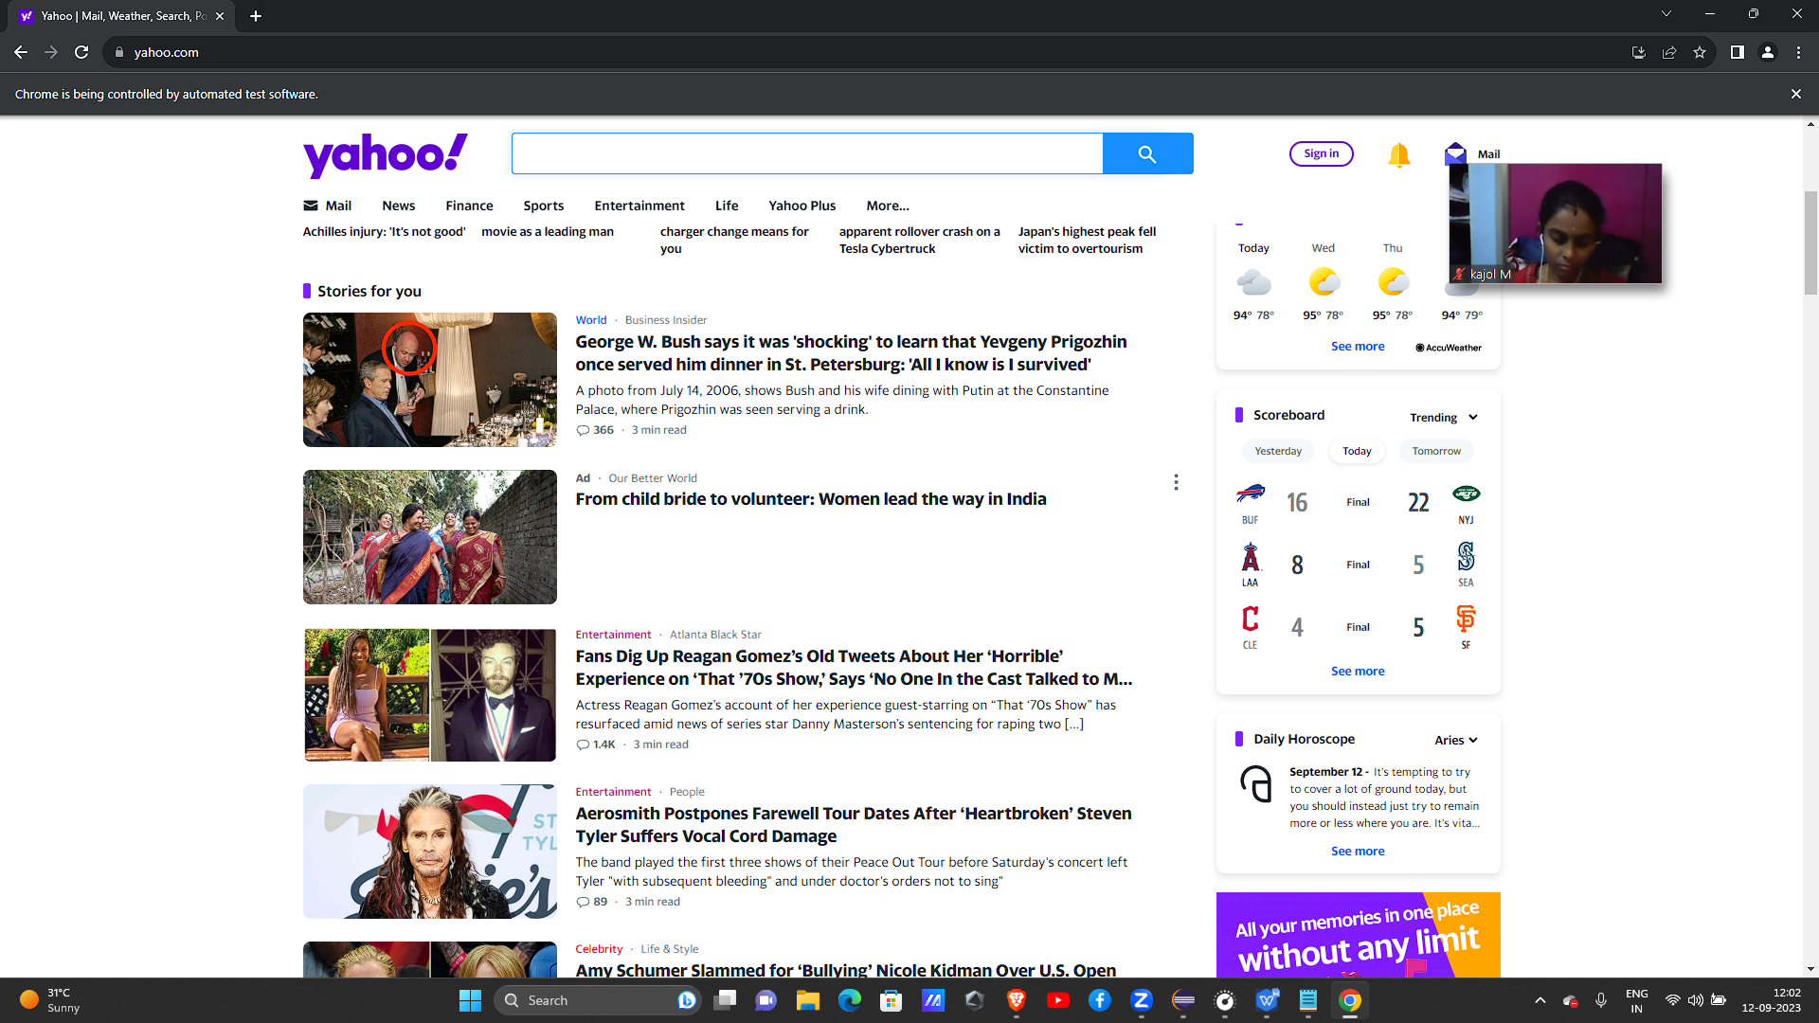

PROGRAM 11:

package firstprogram;

import java.util.List;

import org.openqa.selenium.By;

import org.openqa.selenium.WebDriver;

import org.openqa.selenium.WebElement;

import org.openqa.selenium.chrome.ChromeDriver;

import org.openqa.selenium.support.ui.Select;

public class radiobutton {

public static void main(String[] args) throws InterruptedException{

System.setProperty("webdriver.chrome.driver", "C:/Users/91908/Downloads/chromedriver-win64/chromedriver-win64/chromedriver.exe");

//WebDriver abc1 =new ChromeDriver();

//abc1.get("https://mdbootstrap.com/docs/standard/forms/radio/");

// abc1.findElement(By.className("form-check")).click();

// Validate Radio button using isSelected() methiod

/* WebElement radioElement = abc1.findElement(By.className("form-check"));

boolean selectState = radioElement.isSelected();

//performing click operation only if element is not selected

if(selectState == false) {

radioElement.click();

}*/

WebDriver radiobtn= new ChromeDriver();

radiobtn.get("https://www.facebook.com/signup");

//isSelected

WebElement radio =radiobtn.findElement(By.name("sex"));

boolean isSelected=radio.isSelected();

System.out.println(isSelected);

// performing click operation if element is not selected

if(isSelected==false) {

radio.click();

}

//isDisplayed

/*WebElement radios=radiobtn.findElement(By.name("sex"));

boolean isDisplayed = radios.isDisplayed();

System.out.println(isDisplayed);

if(isDisplayed == true) {

radios.click();

//Thread.sleep(2000);

//radiobtn.quit();

}*/

//isEnabled

/*WebElement radio1=radiobtn.findElement(By.name("sex"));

boolean isEnabled = radio1.isEnabled();

System.out.println(isEnabled);

if(isEnabled == true) {

radio1.click();

//Thread.sleep(2000);

//radiobtn.quit();

}*/

}}

OUTPUT:

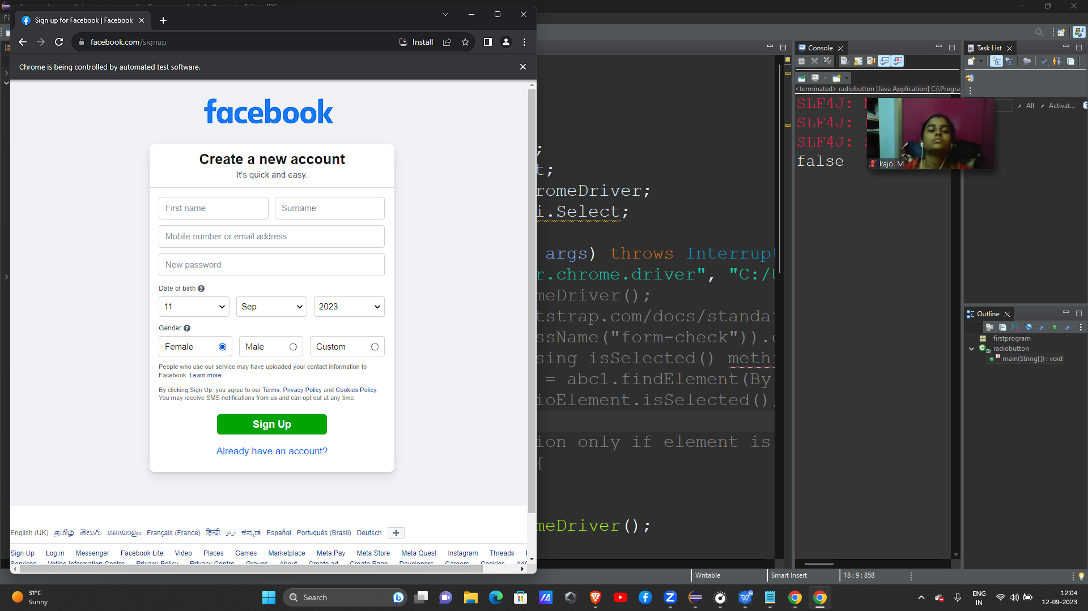

PROGRAM 12:

package firstprogram;

import org.openqa.selenium.Alert;

import org.openqa.selenium.By;

import org.openqa.selenium.WebDriver;

import org.openqa.selenium.WebElement;

import org.openqa.selenium.chrome.ChromeDriver;

public class alert1 {

public static void main(String[] args) throws InterruptedException{

System.setProperty("webdriver.chrome.driver", "C:/Users/91908/Downloads/chromedriver-win64/chromedriver-win64/chromedriver.exe");

WebDriver abc =new ChromeDriver();

WebDriver alert= new ChromeDriver();

//maximize the window

alert.manage().window().maximize();

//deleting cookies

alert.manage().deleteAllCookies();

//get url

alert.get("https://demo.guru99.com/test/delete_customer.php");

//find the element

alert.findElement(By.xpath("/html/body/form/table/tbody/tr[2]/td[2]/input")).sendKeys("78760");

alert.findElement(By.xpath("/html/body/form/table/tbody/tr[3]/td[2]/input[1]")).click();

//1) confirmation alert

System.out.println(alert.switchTo().alert().getText());

Thread.sleep(2000);

//ok button

alert.switchTo().alert().accept();

Thread.sleep(2000);

//dismiss

alert.switchTo().alert().dismiss();

//simple alert

/* abc.get("https://demoqa.com/alerts");

abc.manage().window().maximize();

// This step will result in an alert on screen

abc.findElement(By.id("alertButton")).click();

Alert simpleAlert = abc.switchTo().alert();

simpleAlert.accept();*/

}}

OUTPUT:

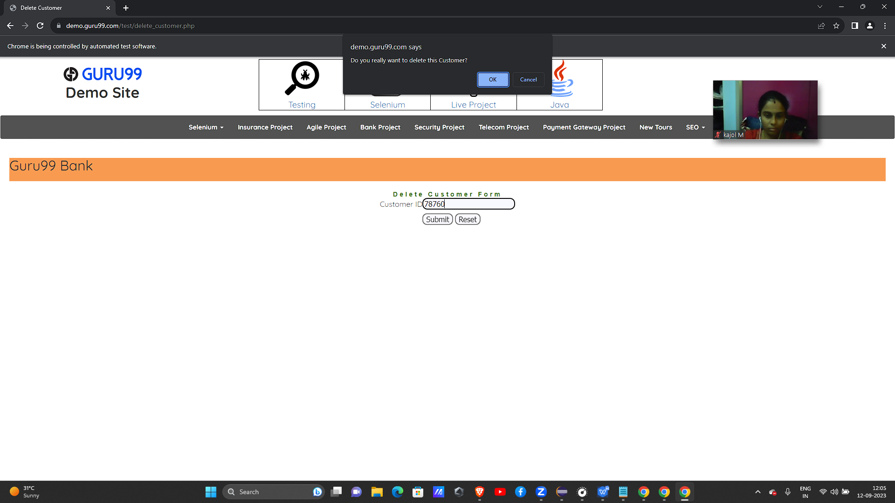

PROGRAM 13:

package firstprogram;

import org.openqa.selenium.Alert;

import org.openqa.selenium.By;

import org.openqa.selenium.JavascriptExecutor;

import org.openqa.selenium.WebDriver;

import org.openqa.selenium.WebElement;

import org.openqa.selenium.chrome.ChromeDriver;

public class alert2 {

public static void main(String[] args) throws InterruptedException{

System.setProperty("webdriver.chrome.driver", "C:/Users/91908/Downloads/chromedriver-win64/chromedriver-win64/chromedriver.exe");

WebDriver alertpr= new ChromeDriver();

//maximize the window

alertpr.manage().window().maximize();

//deleting cookies

alertpr.manage().deleteAllCookies();

//getting url

alertpr.get("https://demoqa.com/alerts");

/*alertpr.findElement(By.id("alertButton")).click();

//1) simple alert

System.out.println(alertpr.switchTo().alert().getText());

Thread.sleep(2000);

//ok button

alertpr.switchTo().alert().accept();

Thread.sleep(2000);

//alert appear after 5 sec

/*alertpr.findElement(By.id("timerAlertButton")).click();

System.out.println(alertpr.switchTo().alert().getText());

Thread.sleep(2000);

//okay button

alertpr.switchTo().alert().accept();

Thread.sleep(2000);

alertpr.switchTo().alert().dismiss();*/

// 3) prompt alert or permission alert

WebElement element = alertpr.findElement(By.id("promtButton"));

((JavascriptExecutor) alertpr).executeScript("arguments[0].click()", element);

Alert promptAlert = alertpr.switchTo().alert();

String alertText = promptAlert.getText();

System.out.println("Alert text is " + alertText);

//Send some text to the alert

promptAlert.sendKeys("Shanthini");

promptAlert.accept();

}

}

OUTPUT:

